|  |  |
| --- | --- |
|  | Report |
|  |  |
|  | Sumaiya Saeha  Student ID: 1905033 |

# How to run the code:

1. My .ipynb file doesn’t require any input. Running all the cells consecutively will suffice. It will automatically generate graphs for PCA (my own code), UMAP and tSNE (library)

# Hyperparameters:

1. Epochs in EM algorithm = 100

# PCA plot:

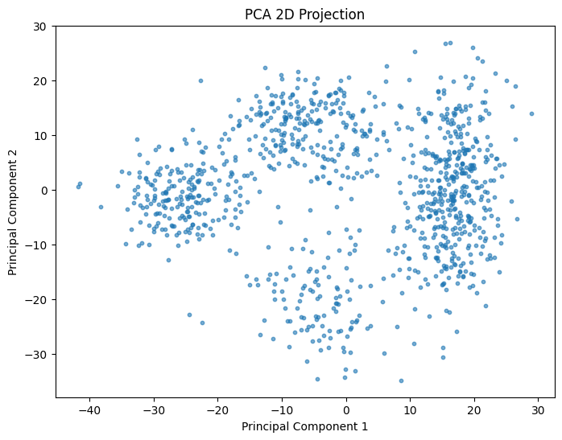

# 

# UMAP plot:

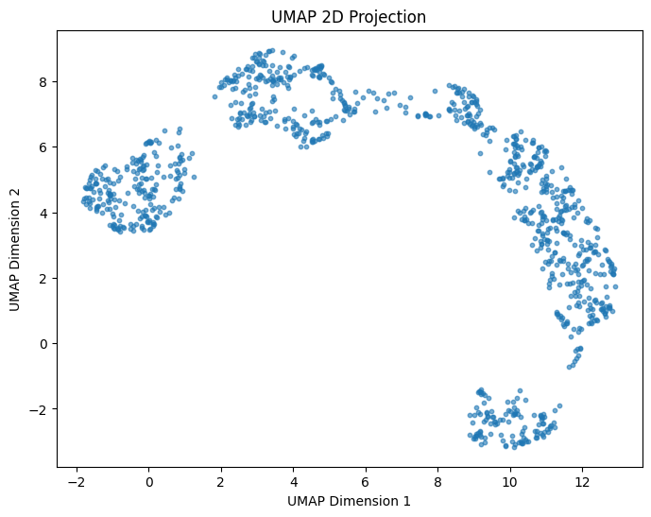

# tSNE plot:

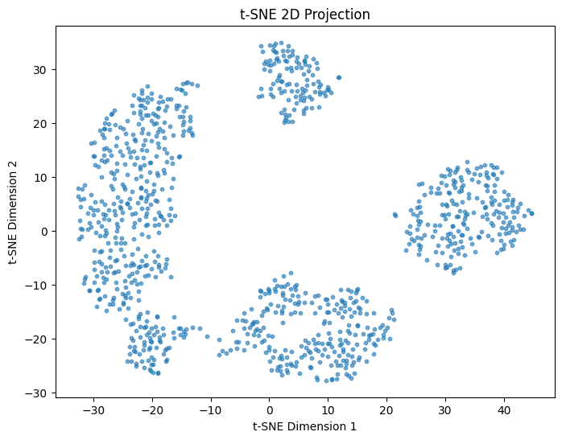

# Estimations:

Mean number of children in families with planning: 1.7825256145266222

Mean number of children in families without planning: 4.910818739390895

Proportion of families with planning: 0.35604679450849747

Proportion of families without planning: 0.6439532054915025